New Entertainment WOW!!!

Twenty-Five plus years working in the entertainment news industry teaches you quite a few things…

Actresses are mostly tiny and insecure.

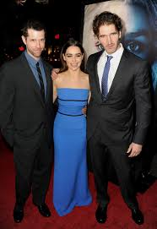
(Some are tiny and badass)

Actors are mostly short and insecure.

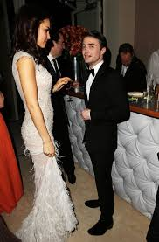
(Some are tiny and cool)
Star publicists are generally a combination of blood-sucking leech and rabid pit bull.

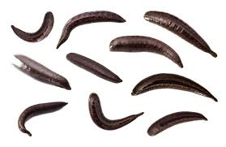
(The 2019 Publicists Awards)

And…
You have actually chosen to work in one of the silliest industries reporting on an even sillier industry as if nothing could be more important than Kim Kardashian shitting her pants at a charity ball for incontinent chihuahuas.

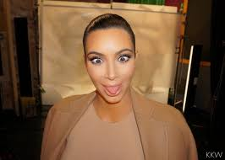
“Gluten-free gelato, my ass!”

We’re at the point where you’d think that today’s entertainment news couldn’t be parodied.

And you’d be right.

That’s why New Entertainment WOW!!! Takes us to a different time, the early days of entertainment news reporting…way back in the 1990’s. Ah, the ‘90’s…

When the internet was radio with occasional, slowly forming pictures.
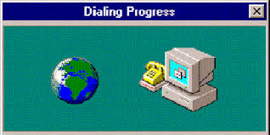

When studios thought that video games would make great movies (oh, sorry, they still seem to think that)

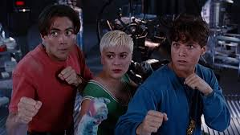
Ummm…I guess they’re…cute?

When TMZ was just a spark in the evil dumpster fire that is Harvey Levin’s brain.

He smiles like this every time he’s secured another soul for hell.

New Entertainment WOW!!! takes a loving look at a time when Social Media was defined as a group of drunks at the Four Seasons bar and getting access to Hollywood stars was more difficult than pretending to like Gwyneth Paltrow.
This comic series follows the adventures of the behind-the-scenes executives, talent and vainglorious peons who sucked up to every starlet, puckered up for every pompous producer and fellated fans (figuratively) by presenting their idols in the best possible light…all while struggling to hold onto a last ounce of dignity…or not.

To read more contact me at scottsgotstories@gmail.com.

