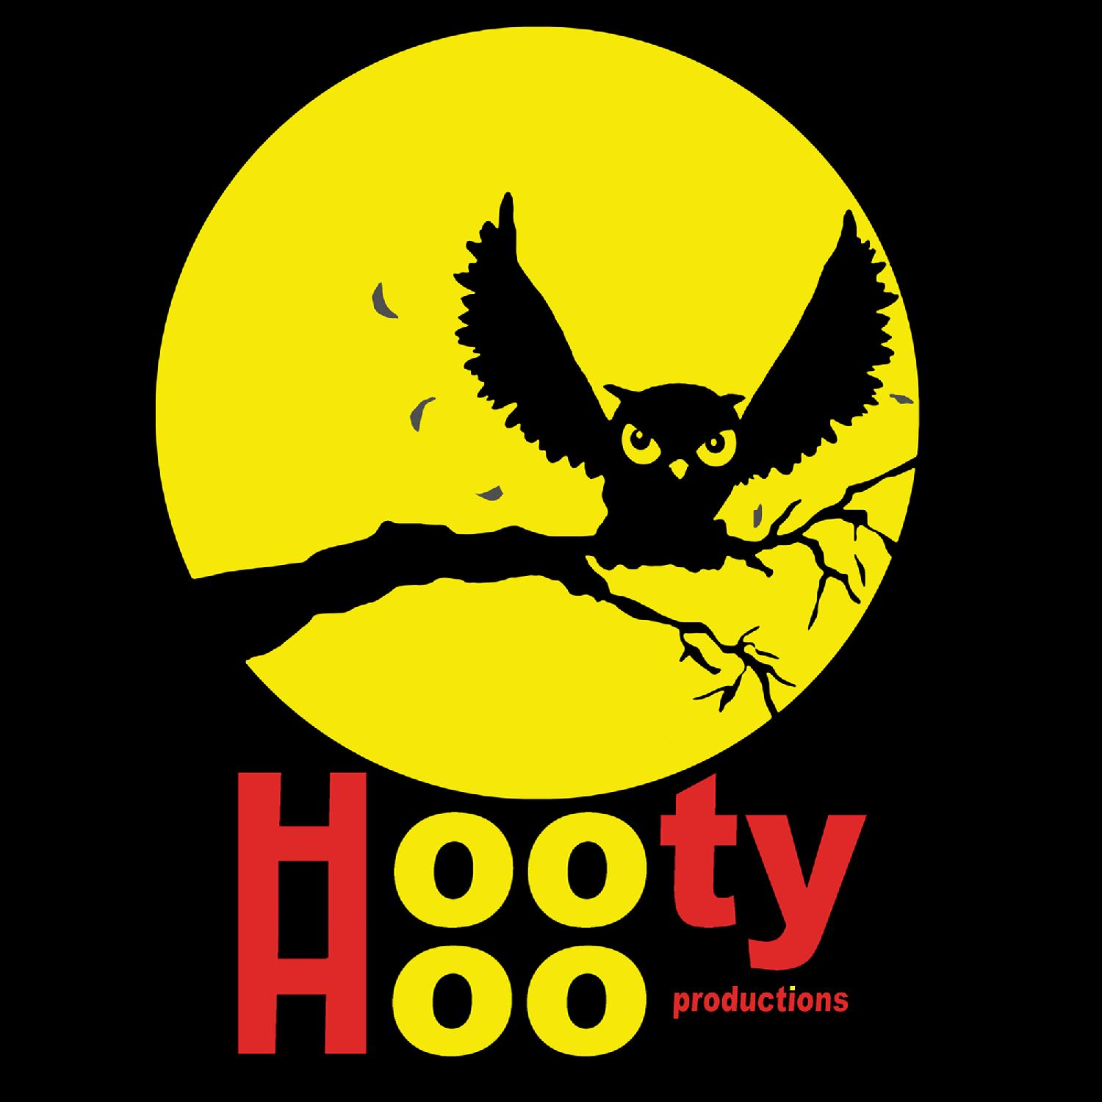
Contact Charles Thomas  Telephone 678-602-7107  Email hootyhooproductions@gmail.com  Website hootyhooproductions.com | FOR IMMEDIATE RELEASE  January 19, 2021

HOOTY HOO PRODUCTIONS OPTIONS FEATURE FILM script “LODGED”

The murder mystery set in an alcohol rehab center, written by first time feature screenwriter Scott Sala, is the first script optioned by the production company.
ATLANTA, GA, January 19, 2021 – Hooty Hoo Productions, the production company behind comedian Eddie Pence’s recent hit comedy special, announced today they have optioned feature film “Lodged” from screenwriter Scott Sala.
Based on Sala’s real experiences in an alcohol rehab center, “Lodged” tells the tale of Ryan, a recovering alcoholic who has hit rock bottom and lost everything. When he enters The Lodge to get his life together, however, he discovers that’s easier said than done when residents begin dying off one by one.
“I didn’t know I was suicidal until I realized, as an alcoholic, I was absolutely killing myself, just slowly,” Sala said. “Lodged, although fictionalized, accurately portrays an addicts painful, sometimes darkly humorous journey away from self-hatred. And there’s a serial killer in the story, too.
“I’m ecstatic to partner with Hooty Hoo Productions. Chuck and Dustin bring passion, talent, and honesty to the creative process.”
“Lodged” is Hooty Hoo Productions’ first optioned feature script. While generally an unscripted production company, co-owners Dustin Jacobs and Charles Thomas always have their eyes open for engaging stories, no matter the format. The duo worked with Sala during the process to workshop the script into its best form.
"Scott and I met at Warner Bros and this has been a story Scott has wanted to tell for some time,” Jacobs said, “so clearly I'm honored to have helped develop it and now option it for Hooty Hoo Productions."
“As a screenwriter, it’s been fulfilling to help a first-time writer develop his idea,” Thomas said, who is also on the board of non-profit Film Impact Georgia. “Scott was very open to new ideas and notes which made the process smooth. As a result, we have a script ready to surprise and shock people.”
The production company has already begun reaching out to several named actors to be disclosed at a later time.
About Hooty Hoo Productions:
Hooty Hoo Productions is a Georgia-based production company with an office in Los Angeles. The company specializes in unique unscripted and scripted content, whether it’s in the form of a web series, a comedy special, a music video, or a feature film. They strive to be forward-thinking about content to showcase the unseen and unknown. More info about the company can be found at hootyhooproductions.com.
# # #
If you would like more information about this topic, please contact Charles Thomas at 678-602-7107 or email hootyhooproductions@gmail.com.

